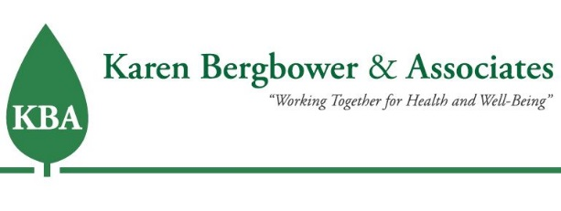
SUBSTANCE ABUSE PREVENTION
FY 2020 - 2021 Program Brief
REDUCING YOUTH ACCESS TO TOBACCO and VAPING
WASHTENAW COUNTY
Karen Bergbower & Associates (KBA) works with local schools, coalitions, and the Michigan State Police to educate tobacco retailers about the Michigan Youth Tobacco Act, reduce youth access to tobacco, and conduct tobacco compliance checks.
Michigan Department of Education, Michigan Profile for Healthy Youth, High School Survey results, 2017-2018 and 2019-2020
When looking at the above chart, you will see our work with retailers is paying off! There is a significant drop in the percentage of students who bought their electronic vapor products in stores/gas stations. We applaud our retailers for helping to keep tobacco and vaping products out of the hands of youth!
Tobacco Compliance Checks SYNAR and Non-SYNAR
“The federal Synar Amendment requires states to have laws in place prohibiting the sale and distribution of tobacco products to person under 18 years-of-age and to enforce those laws effectively. Annual Synar checks, required by the amendment, show that great strides have been made the reduction in retailer violations of the law and youth access to tobacco products in Michigan.”
*Michigan Department of Health and Human Services

During 2020-2021,
239 retailers
received vendor education by phone.
80% of retailers
were found to be in compliance with the Youth Tobacco Act.

Due to COVID we were unable to do face-to-face vendor education. Instead, we called all the tobacco retailers in the area to check in with them and to remind them that you now need to be 21 years old to purchase any tobacco products.
We were also unable to do non-Synar (law enforcement) checks. However, when we conducted our Synar checks, most of our retailers did not sell to our decoys. The retailers that failed their check will receive additional vendor education to ensure they don’t fail again.
We are hoping that in the upcoming year we can get back to a somewhat “normal” schedule and meet with our retailers face-to-face.

