Overview
The CMHPSM credentialing/re-credentialing form is to be used for initially applying to become a CMHPSM SUD provider, as well as on a biennial (every 2 years) basis to meet the re-credentialing standards. Providers must retain credentialed status to be eligible to contract with any of the Community Mental Health Service Providers (CMHSPs) within the CMHPSM region. This application may be updated from time to time, and the most recent version must always be used when applying or re-applying.
- Acceptance to the CMHPSM provider network means your organization has been deemed eligible to contract with the CMHSPs during the credentialed term. Acceptance to the CMHPSM network does not guarantee a service contract will be issued by any or all of the CMHSPs within the CMHPSM region. Please review the current CMHPSM Organizational Credentialing & Monitoring Policy (found at https://www.cmhpsm.org/regional-policies) for further guidance.
- Providers will receive written documentation related to their application submission acceptance or denial.
- Providers must remain cognizant of their credentialed term and re-apply prior to that term expiring to remain eligible to contract with the CMHSPs.

Submission requirements:
The application is a point-in-time review of organizational requirements as of the application date identified. Contractually required documentation must be kept current at all times during the contract period and will also need to be submitted in between credentialing application submissions (i.e., Accreditation, Insurance, and Debarment Status). Please update your credentialing contact as soon as possible should any changes occur.

All required applications, attachments and documentation should be submitted by email to your local CMHSP contract or network management contact. The main application and attachments must be completed electronically. No handwritten applications or attachments will be accepted. Electronic signature is preferred. Please submit application materials in the following formats:
- Credentialing Application, Attachment D: PDF file (.pdf) or Word document (.doc, .docx)
- Attachments A-C: Excel (xls, .xlsx) or PDF file(.pdf)
- All other required documentation: PDF file (.pdf).

The application will not be reviewed until all required materials have been submitted. All fields are required; if they do not apply to your organization, please mark “n/a” unless otherwise indicated. Applications with missing information will be returned for completion. Once all required materials have been submitted, you will receive a credentialing decision within 90 days. As part of the verification process, additional documentation may be requested following the initial application.

Please reach out to your local credentialing contact or contracts@cmhpsm.org with any questions regarding the application process or related to the required trainings. CMHSPs may have additional training requirements or a preferred documentation method.

Instructions
The top of the page contains a section for CMHPSM/CMHSP use; do not type in this box.
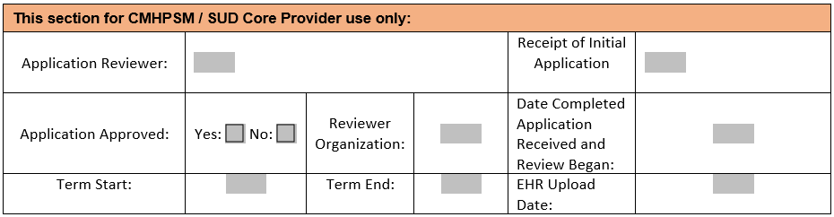

Section 1: Application Information
- Click check boxes to create an X. Text boxes will expand as you type.
- Select whether you are applying for an initial credential or recredentialing. The Application Date refers to the date you are submitting the application and all required materials.
- Include contact information for the staff person that the credentialing entity can contact regarding questions related to the application.

Section 2: Organizational Information
- Complete all applicable organizational information.
- Include all sites you are requesting to credential, their license numbers, and the ASAM levels of care provided at each site.
  - If you have received MDHHS ASAM Certification letters by the time of application, mark “Yes” in the right-hand column. If not, mark “No.”
  - If you are applying for initial credential, please attach any ASAM letters with your application materials. If you are applying for recredential, please ensure the CMHPSM is listed as recipient for your letters from MDHHS.
- Include the name and primary contact information for each administrative contact at your agency. If your agency does not have the position, enter “n/a”.
- If you would like CMHPSM to send notifications of added/changed authorizations to your organization, provide an email address. Otherwise, enter “n/a”.
- For the section beginning “Within the five years preceding the application date…”, if any answer is “Yes”, additional information is required. Please attach a document (.pdf) with a detailed accounting of the incident(s) and current status.
- Select the SUD service panel(s) and populations your organization is requesting to serve. Please list any services your organization provides that are not on the list of services. Your organization can expand beyond the services or consumer populations initially selected.
  - Identify which sites (by site # on the Organization State Licensing Information section) provide that service.
  - For service panels related Women’s Specialty Services, your organization must submit proof of certification to provide and bill for these services. Please submit the related designation document(s) from MDHHS as a .pdf file.

Section 3: Provider Contractual Requirements
- Please document your organization’s current accreditation status and accrediting body.
  - Joint Commission
  - CARF - Commission on Accreditation of Rehabilitation Facilities
  - COA - Council on Accreditation
  - NCQA - National Committee for Quality Assurance
  - Other: Please list your accrediting bod. All other accreditations will be reviewed to ensure the standards match CMHPSM requirements.
  - If you have received an accreditation waiver, please check the related box.
  - Enter the effective date and expiration date for your accreditation(s).
  - Attach a copy of your accreditation letter/verification in .pdf format.
- Indicate whether your sites (service provision and administrative) are ADA compliant.
  - Check the boxes as applicable for each of your sites.
- Enter the hours you are available to provide services. If you provide 24-hour services, check the boxes in the second row. For other hours, enter the time open and time closed.
- Review the insurance requirements. Attach verification documents (ROI) for your insurance policy/policies in .pdf format and check to boxes to indicate which are attached.
  - For additional information about the Fidelity Bonding program, click the blue hyperlink in the box to visit the Michigan Office of Labor & Economic Opportunity website.
- Indicate in which areas your organization has expertise, specialized training, or certification.
  - If you are accepted into the provider network, these specialties will be listed on your public profile.
- List all special substance use disorder service certifications the organization has obtained, including certification types and expiration dates. If not applicable, enter “n/a”.
- List all special substance use disorder service certifications and/or licenses staff members of the organization have obtained. Specify all certified/licensed staff names and type of certification/licensure.
- Identify all Substance Abuse Certified Clinical Supervisor CCS-M or CCS-R staff responsible for supervising all Substance Abuse Treatment Specialists (SATS). Enter both supervisor and supervised staff members and their credentials.
- List any linguistic capacity other than English your organization currently has.
  - Notate any staff members who are fluent in additional languages other than English or briefly describe linguistic capacity for that language.
  - List any external translation service used.
- Provide 3-5 references to agencies your organization contracts with for mental health services. At least 3 references are required.

Section 4: Staff Information Attachments
- Document that each required attachment (A, B, C, and D) is attached and note the number of pages. The information should reflect the makeup of the organization as of the application date. Please see above for accepted file formats.
- Backup or more extensive documentation may be requested on a sample of employees during the credentialing period, upon site visits or desk audits.
- Please identify the staff the CMHPSM would contact related to the information entered into these attachments. All fields are required. If the same staff member is responsible for all three roles, enter “same.”

Section 5: Provider Certification, Release, & Signature
- Read and attest to the disclaimer and have the designated representative sign and date the document. Indicate the title of the signing representative. According to the ESIGN Act of 2000 the designated representative can sign the document by typing his or her name into the signature box.

