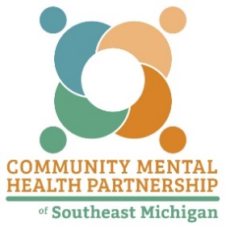
CMHPSM RFP#2025D- Appendix E Resources

Recovery Oriented Systems of Care (ROSC) Model:
https://www.samhsa.gov/sites/default/files/rosc_resource_guide_book.pdf

SMART Recovery Stages of Change:
https://smartrecovery.org/the-stages-of-change

Michigan Association of Recovery Residences (MARR):
https://michiganarr.com/

Government Performance and Results Modernization Act (GPRA):
https://www.samhsa.gov/grants/gpra-measurement-tools

CMHPSM Procurement:
https://www.cmhpsm.org/procurement

CDC Writing SMART Objectives:
https://www.cdc.gov/healthyyouth/evaluation/pdf/brief3b.pdf

FY24-26 CMHPSM Substance Use Services Strategic Plan:
https://www.cmhpsm.org/strategicplan

